Process of setting up a new repository on GitHub.
Steps
1.
In the upper-right corner of any page select + then click New repository.
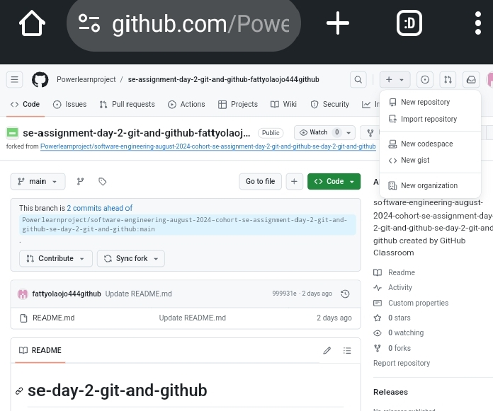
2. Type a short, memorable name for the repository. For example, "PLP Assignment".
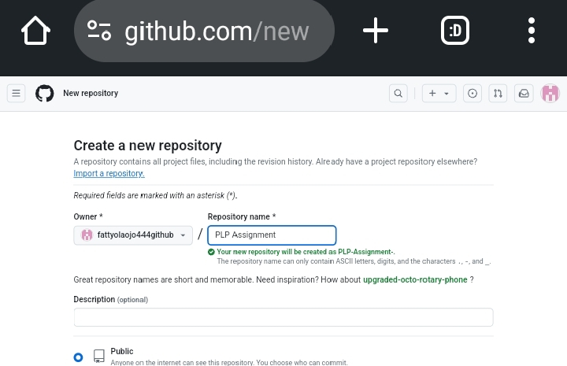
3. Optionally, add a description of your repository. For example, "My first repository on GitHub."

4. Choose a repository visibility.

5. Select Initialize this repository with a README.

6. Click Create repository.
Congratulations! You've successfully created your first repository, and initialized it with a README file.

